Lab5: Graphic, Input handling and Sound: Shooting Game

(Part 2)

Section 1 Date 18/11/2558

Student ID 5731015621 Name Jirapat Atiwattanachai

# Important Rules

* Any cheating (copying code, answer, picture, etc.) causes the lab’s score to be “**0**”.
* Any screenshots must be from YOUR own program.
* If the captured screenshot (e.g., JUnit Test Case) and the result of your program are different, the lab score will be “**0**”.
* Please put the following code in the top of ALL of your codes.

/**

* **@author** Your name (Your ID)

* **@version** 3 Apr 2015

* Lab5 part2 (2/2014) in 2110215 Prog Meth

*/

# Objective

* Finish Lab 5 (part 2).
* Create runnable JAR file called “Lab5_part2_{ID}.jar”
* Zip your Eclipse project folder in the file called “Lab5_part2_project_{ID}.zip” (Make sure that source codes included)

# Part A: Shooting Game (11 points)

1. Try to run ShootingGame.exe and capture screenshot of the game.

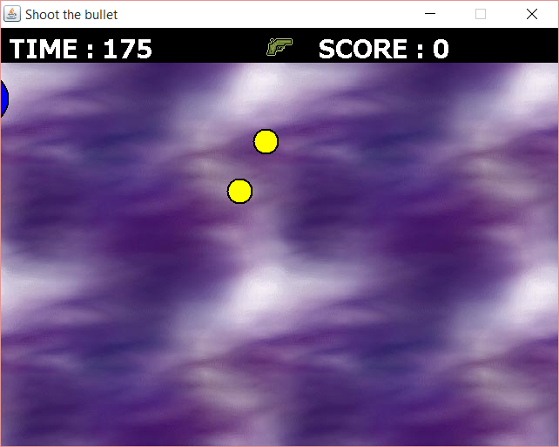

1. After finishing “GameAnimation.java”, run JUnit Test Case “TestGameAnimation.java” and then capture the result.

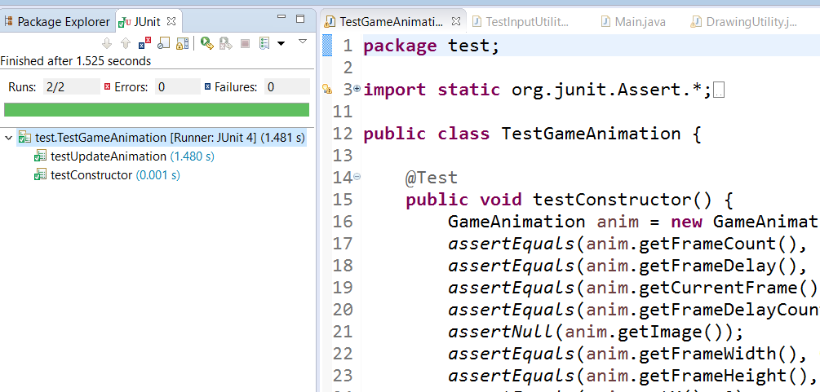

1. After finishing “InputUtility.java”, run JUnit Test Case “Test InputUtility.java” and then capture the result.

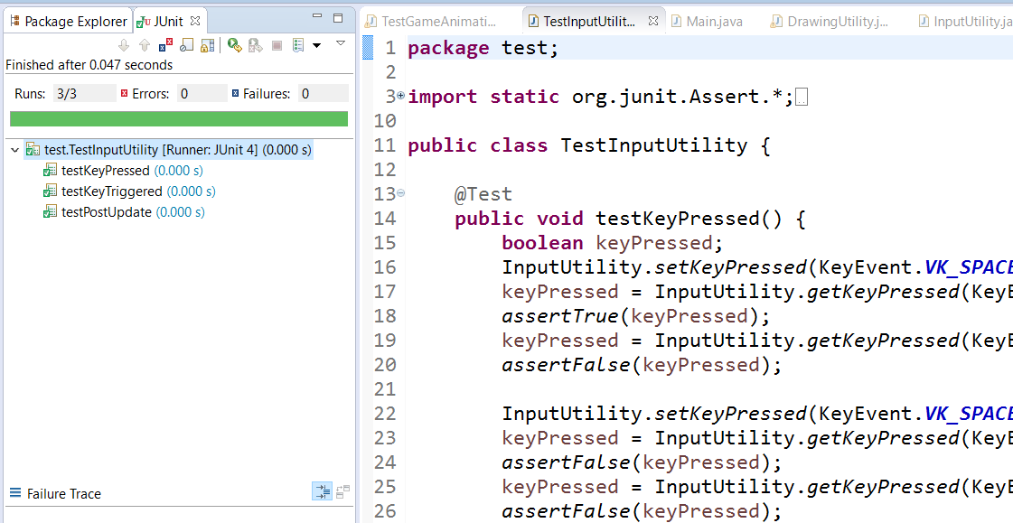

# Part B: Implementation (19 points)

1. Implement the ShootingGame and check finished event using “🗸” in “Student Checker” column from the below table.

|  |  |  |  |  |  |  |  |
| --- | --- | --- | --- | --- | --- | --- | --- |
| **No** | **Classes** | **Methods** | **Events** | **Points** | | **Sub Points** | **Student Checker** |
|  |  | drawShootableObject(…) | **Draw all circular objects include 2-pixel black border correctly** | 4 | |  |  |
| 1 | - simple : blue | 1 | 🗸 |
| 2 | - splitter : red | 1 | 🗸 |
| 3 | - small : yellow | 1 | 🗸 |
| 4 | - If mouse over objects, highlight must be drawn on top of the object. | 1 | 🗸 |
|  | drawItemGun(…) | **Draw all gun items correctly** | 2 | |  |  |
| 5 | - Gray circular object with 2-pixel black border. | 1 | 🗸 |
| 6 | - If mouse over objects, highlight must be drawn on top of the object. | 1 | 🗸 |
| 7 | Draw gun icon on the items | 2 | |  |  |
| 8 | - Normal gun with unlimited bullets (gun_inf.png) at the center | 1 | 🗸 |
| 9 | - Special gun (gun.png) at the center | 1 | 🗸 |
|  | drawItemBullet(…) | **Draw bullet correctly** | 3 | |  |  |
| 10 | - Gray circular object with 2-pixel black border. | 1 | 🗸 |
| 11 | - Bullets image (overlapping rectangle and oval) at the center | 1 | 🗸 |
| 12 | - If mouse over objects, highlight must be drawn on top of the object. | 1 | 🗸 |
|  | drawStatusBar(…) | **Draw status bar correctly** | 3 | |  |  |
| 13 | - Black stripe includes remaining time and player score. | 1 | 🗸 |
| 14 | - “PAUSE” at the center of the screen when the game is paused | 1 | 🗸 |
| 15 | - Pressing ENTER changes the game status between playing and pausing. | 1 | 🗸 |
| 16 |  | - Run your JAR file and check all images in the game that can show correctly (Including background, gun, infinite gun, and shooting animation) | 2 | | |  |
| 17 | render.AudioUtility |  | - Play shooting sounds and getting the correct sound | 3 | 1 | | 🗸 |
| 18 | - Run your JAR file and check gun sounds that can get sounds correctly | 2 | | 🗸 |
| **Total** | | | | **19** | | | **19** |